Report Page

Wireframe Designs:
1. Wireframe Inspiration for Main and References pages
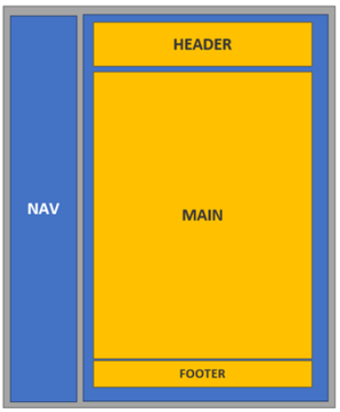

2. Wireframe Inspiration For Speed, Vintage, References, MetaPage pages
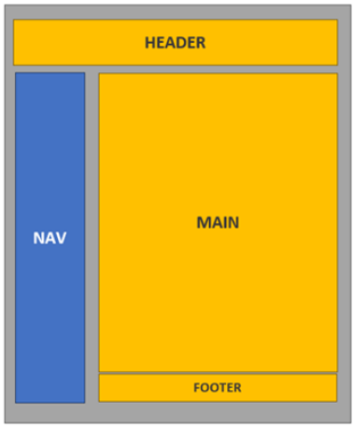

3. Wireframe Contact Page
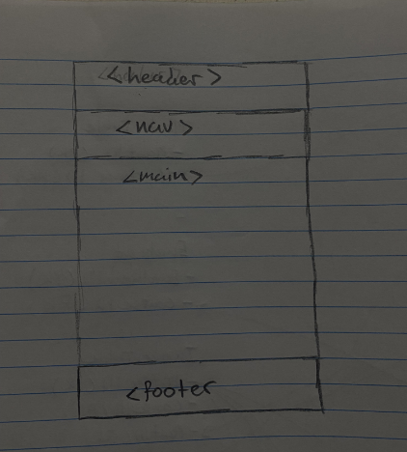
Wireframe Reference Page
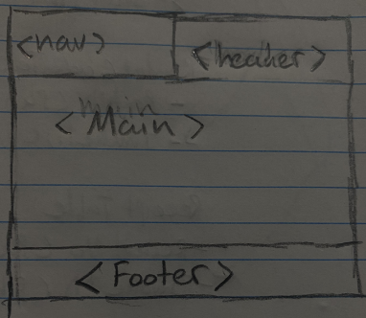

Wireframe for Reference Page
Webpage sitemap:

